Software Requirement Specification Document

For

Interactive Learning Platform

Table of Contents
Page Numbers
- Introduction 3
  - Purpose 3
  - Intended Customers/Users 4
  - Product Scope 5
  - Outline of the document 5
- Overall Description 6
  - Product Perspective 6
  - Product Functions 6-7
  - User Classes 7
  - Design and Implementation Constraints 8
- Diagrams
  - UML Diagrams 9-30
  - ER Diagrams 31
  - DFD Diagrams 32
- External Interface Requirements/Screenshots 33
  - User Interfaces 33
  - Hardware Interfaces 34
  - Software Interfaces 34
  - Communication Interfaces 35
- Other Non-Functional Requirements 36
  - Performance Requirements 36
  - Safety Requirements 36
  - Security Requirements 37
  - Software Quality Attributes 37
  - Business Policies/Rules (if any) 37-38
- Testing 39
  - Block-Box Testing 40-44
  - White-Box Testing 45-52
- Conclusion 53
- References 54
- Acknowledgements 54
- Design Architecture 55-

1. Introduction
The Interactive Learning Platform is an online software system created to assist students and teachers by providing a digital environment for learning activities.The system aims to make learning more interactive, organized, and accessible beyond the traditional classroom environment.

The platform allows students to access learning materials, attempt quizzes, and track their progress, while teachers can manage content and assessments in a simple manner.
1.1 Purpose
The Interactive Learning Platform is developed to improve the overall learning experience by providing an online system that supports both teaching and learning activities.
This software is being developed to
- Provide a digital platform for students to learn anytime and anywhere
- Reduce dependency on classroom-only learning methods
- Support self-learning and revision through online content and quizzes
Problems it solves
- Difficulty in accessing learning materials from different sources
- Manual handling of assignments and assessments
- Limited interaction in traditional online learning systems
This SRS document contains
- An overview of the system and its objectives
- Description of users and major system features
- Overall behavior, scope, and limitations of the system

1.2 Intended Customers/Users
The Interactive Learning Platform is intended for different users who interact with the system based on their assigned roles.

Primary users of the system:

Students
- Access learning materials such as notes and documents
- Attempt quizzes and assessments
- View results and track learning progress
Teachers
- Upload study materials
- Create quizzes and assignments
- Monitor student performance
Administrators
- Manage user accounts
- Control system settings
- Maintain data consistency and security
Management
- Review overall learning progress
- Analyze system usage at a high level

1.3 Product Scope
The product scope highlights the major functionalities that the Interactive Learning Platform is intended to provide.
The system focuses only on essential learning and assessment features.

Main capabilities of the system
- User registration and secure login
- Course creation and enrollment
- Uploading and accessing learning content
- Online quizzes and simple assignments
- Automatic evaluation and result display
- Student progress tracking

1.4 Outline of the document
This document is organized into chapters to clearly explain system requirements.
• Chapter 1 covers introduction purpose users and scope
• Chapter 2 explains overall system description

2. Overall Description
This chapter provides a general overview of how the Interactive Learning Platform operates.
• Describes the system environment
• Explains major system capabilities

2.1 Product Perspective
The platform functions independently and does not rely on or integrate with any existing software systems.

System environment
- Web-based application
- Accessible through standard web browsers
- Uses a backend database for storing data
System nature
- Standalone system
- Not part of any existing software
External systems interaction
- Interacts with a database for storing user details, course content, and quiz results

2.2 Product Functions
The Interactive Learning Platform provides the following major functions.
Core features
- User authentication and authorization
- Course creation and enrollment
- Learning content delivery (notes, videos, documents)
- Online quiz creation and submission
- Automatic evaluation of quizzes
- Display of results and learning progress
Supporting features
- Simple and user-friendly navigation
- Role-based access control
- Basic feedback to users

2.3 User Classes
The system supports multiple user classes with different access levels.

Student
- View learning materials
- Attempt quizzes
- Check results
Teacher
- Upload and manage content
- Create and evaluate quizzes
- View student performance
Administrator
- Manage users
- Configure system settings
- Maintain database

2.4 Design and Implementation Constraints
Hardware Limitations
- Depends on server capacity
- Performance may vary with number of users

Software Requirements
- Requires a modern web browser
- Requires a backend server and database

Network Dependency
- Stable internet connection is required
- Offline access is not supported

Database Limitations
- Limited storage based on server configuration

Browser-Specific Issues
- Best performance on updated browsers
- Older browsers may have compatibility issues

Security Constraints
- User data must be protected
- Proper authentication is required to access the system

3. Diagrams
  - UML Diagrams
Use Case Diagram

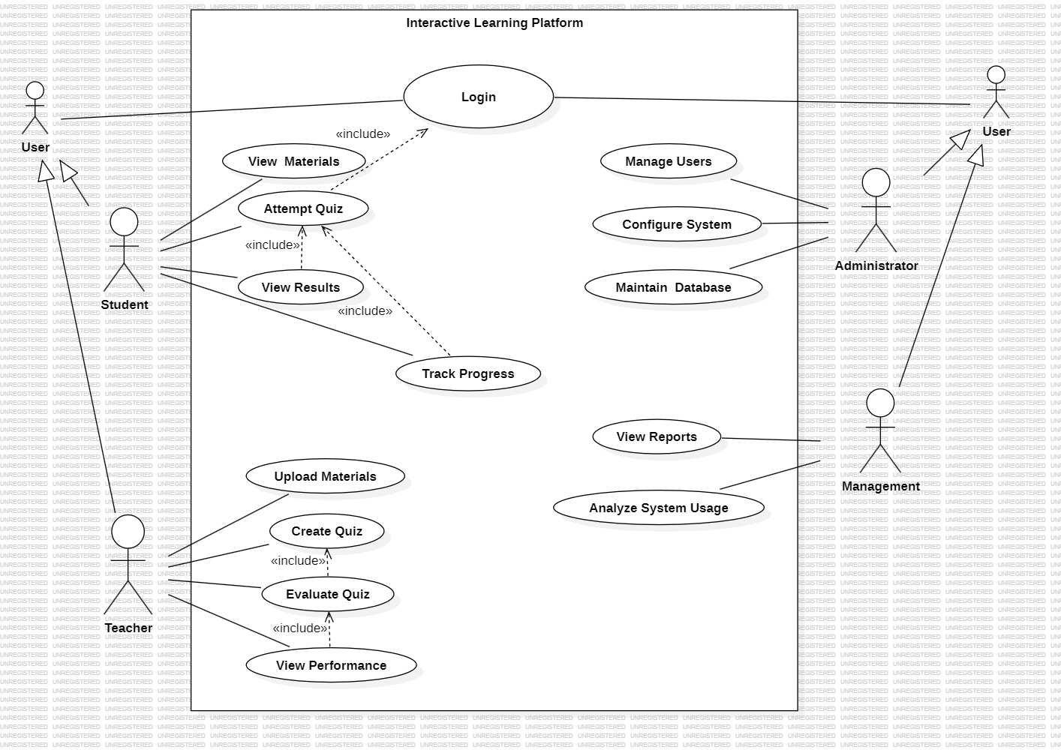

Overview
    - The use case diagram represents the functional behaviour of the Interactive Learning Platform.
    - It shows how different actors interact with the system.
    - The diagram helps in understanding the system scope and requirements.
    - Login is mandatory for accessing most system functionalities.
Actors in the System
User
- A general actor for all users.
- Provides common functionality such as login.
Student
- Uses the platform for learning and assessment.
- Accesses materials, quizzes, and results.
Teacher
- Responsible for academic content and evaluations.
- Creates quizzes and reviews student performance.
Administrator
- Manages users and system configurations.
- Maintains the system database.

Management
- Monitors system usage.
- Views reports and analytics.
Student Use Cases
- Login
Required to access the system.
- View Materials
Allows students to view learning resources.
- Attempt Quiz
Enables students to attempt quizzes.
- View Results
Displays quiz scores after submission.
- Track Progress
Helps students monitor academic progress.
Teacher Use Cases
- Upload Materials
Uploads notes and learning content.
- Create Quiz
Creates quizzes for courses.
- Evaluate Quiz
Evaluates student quiz submissions.
- View Performance
Analyses student performance reports.

Administrator Use Cases
- Manage Users
Adds, updates, or removes users.
- Configure System
Manages system settings.
- Maintain Database
Ensures database integrity and consistency.

Management Use Cases
- View Reports
Views reports related to system performance.
- Analyse System Usage
Analyses overall platform usage and activity.

Relationships in the Diagram
- <<include>> Relationship
  - Login is included in most use cases.
  - Attempt Quiz is included in View Results.
- Generalization
  - Student, Teacher, Administrator, and Management inherit from User.

Class Diagram
1.User Management Module
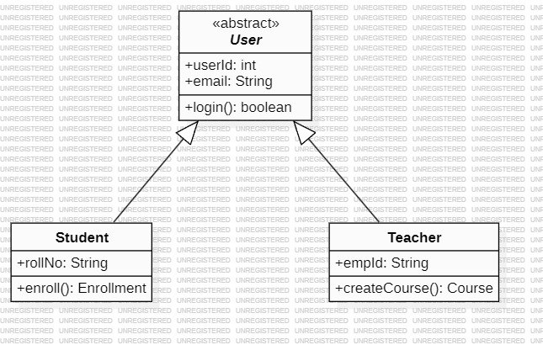

This module handles user-related functionalities of the system. It includes different types of users such as Student and Teacher. The User class acts as a base class and provides common functionality like login.

2.Course Management Module
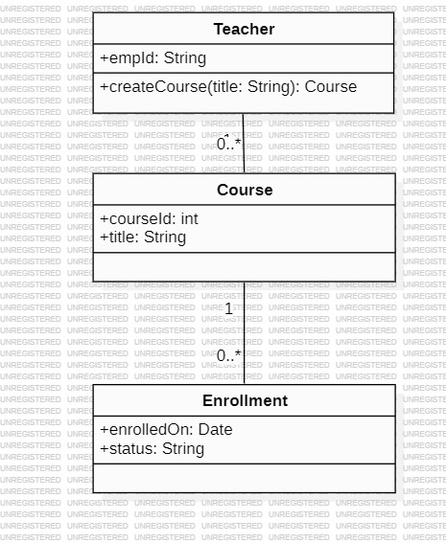
This module manages course creation and enrolment details. Teachers create courses, and enrolment information is maintained for each course.

3.Content Management Module
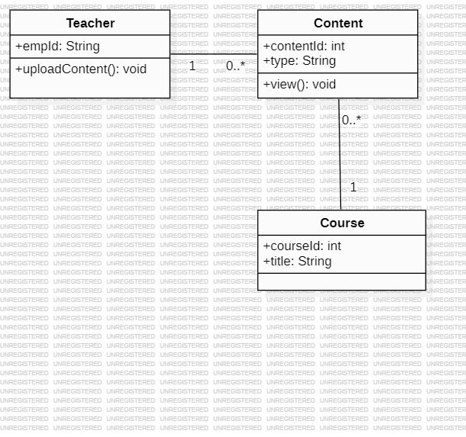
This module manages learning materials uploaded by teachers. Content is associated with courses and can be accessed by students.

4.Assessment (Quiz) Module
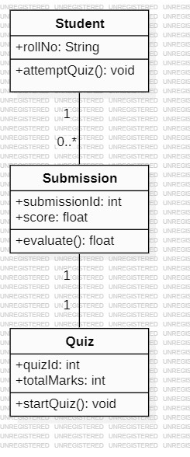
This module handles quiz attempts and evaluation. Students attempt quizzes, submit their answers, and submissions are evaluated to generate scores.

5.Enrolment & Progress Module
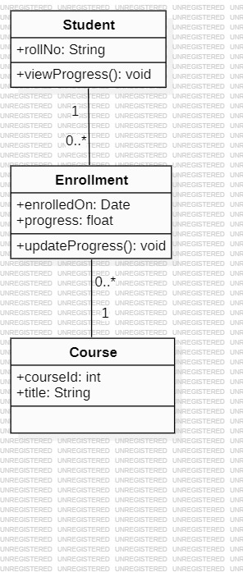
This module manages course enrolment and tracks student progress. When a student enrols in a course, an enrolment record is created, and progress is updated throughout the course duration.
State Chart Diagram
1.Quiz
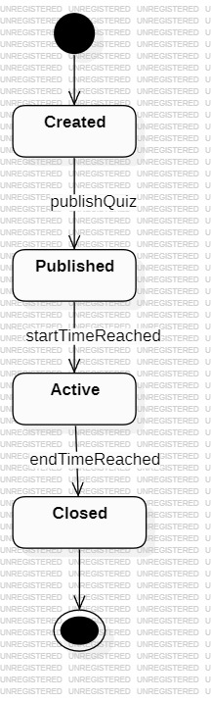
This state chart diagram shows the lifecycle of a quiz. Initially, it is in the created state. After it is published, it moves to the published state. When the start time is reached, it becomes active, and finally it transitions to the closed state.
2.Submission
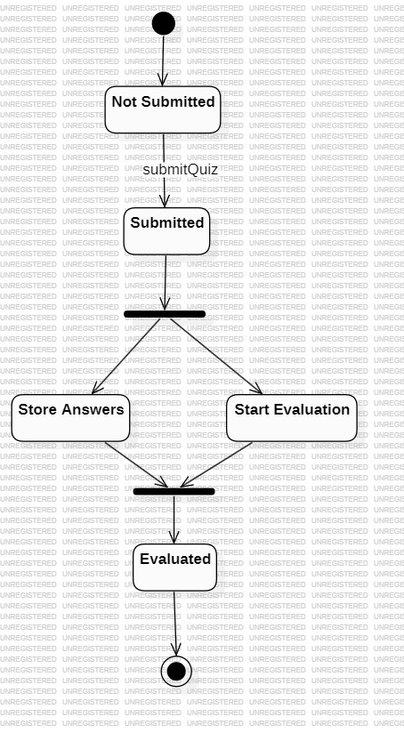
This state chart diagram shows the lifecycle of a submission. Initially, the submission is in the not submitted state. After the student submits the quiz, it moves to the submitted state. Finally, after evaluation, the submission transitions to the evaluated state.

3.Student (Quiz Activity)
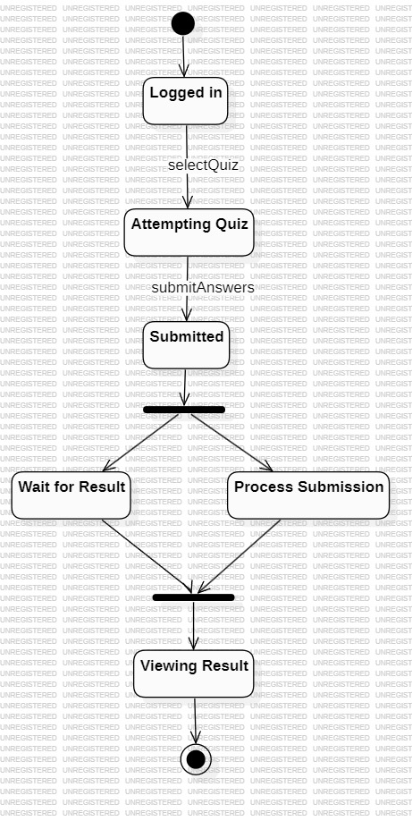
This state chart diagram shows the states a student goes through while attempting a quiz. After logging in, the student attempts the quiz and submits the answers. The system processes the submission while the student waits for the result. Finally, the student views the quiz result.

Activity Diagram
- Enrolment & Progress Module
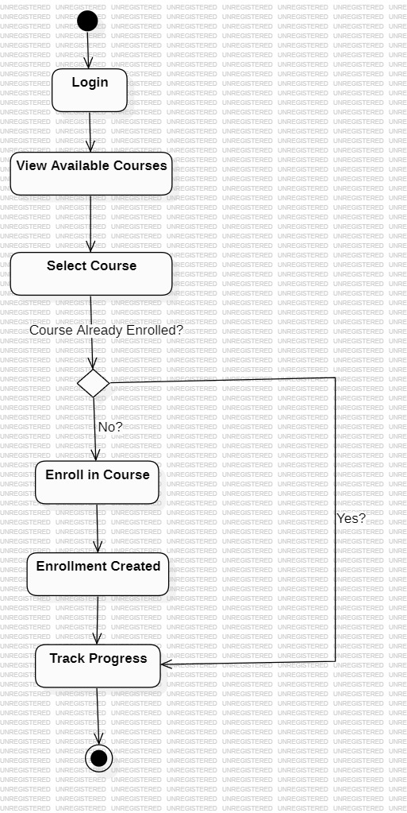
This activity diagram shows the workflow of course enrolment and progress tracking. The student selects a course, enrols if required, and tracks progress.

Assessment (Quiz) Module
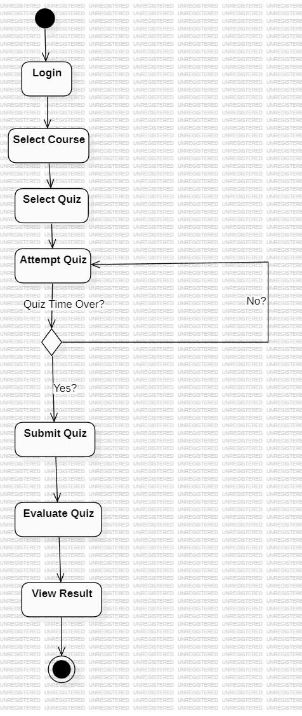
This activity diagram shows the sequence of activities involved in attempting a quiz. The student logs in, selects a course and quiz, attempts the quiz, submits answers, and finally views the result after evaluation.
Sequence Diagram
1.Quiz Start and Attempt
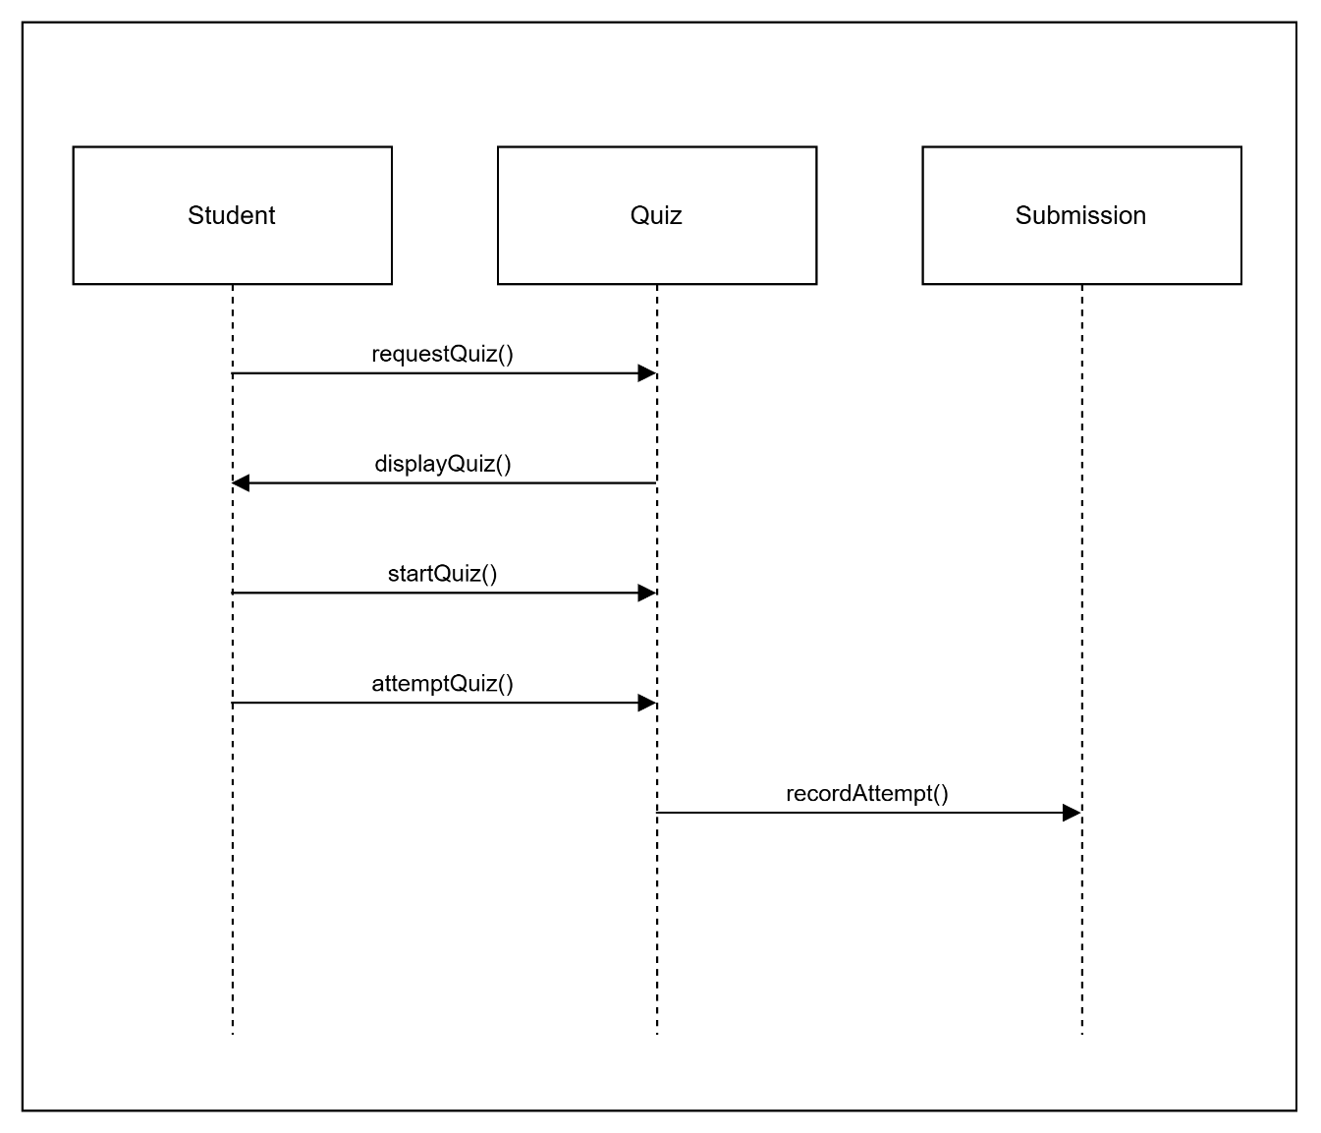
- This sequence diagram represents the interaction between Student and Quiz during the quiz initiation process.
- It shows how a student requests a quiz, starts it, and begins attempting questions.
- The diagram focuses on the initial phase of quiz interaction.

- Quiz Submission and Evaluation

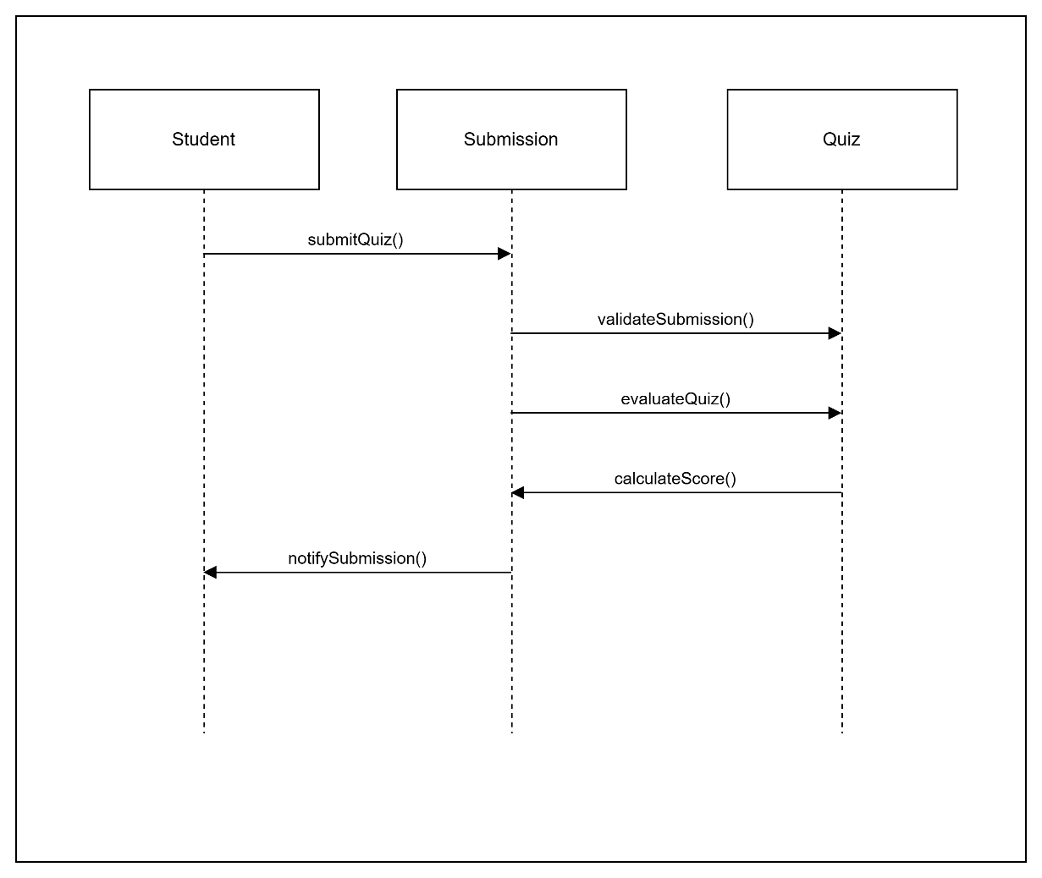
- This sequence diagram illustrates the process of quiz submission and evaluation.
- It shows how the student submits answers and how the submission is evaluated to generate a score.
- The interaction between Submission and Quiz is emphasized.

3.Quiz Submission and Evaluation
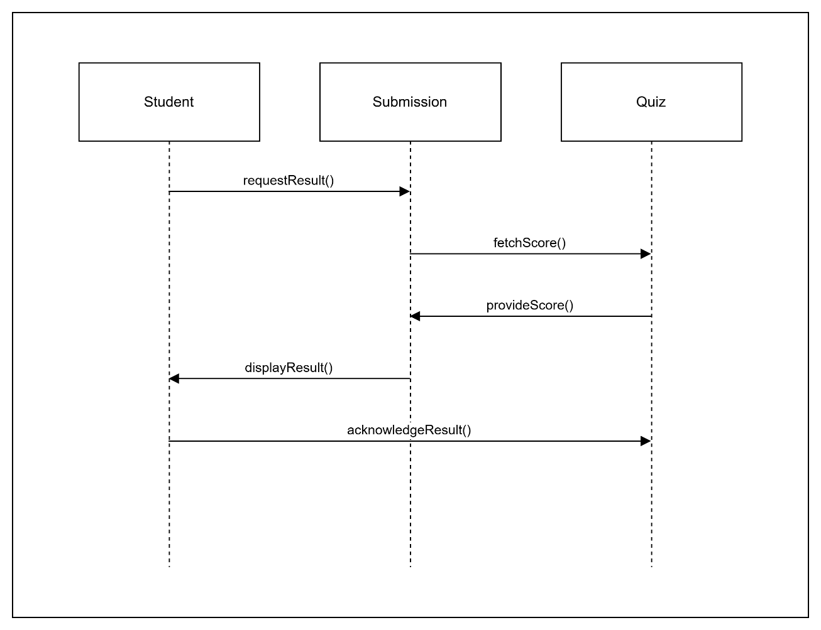
- This sequence diagram shows how a student views quiz results after evaluation.
- It represents the interaction needed to fetch and display the quiz score.

Collaboration Diagram
1.Quiz Start and Attempt
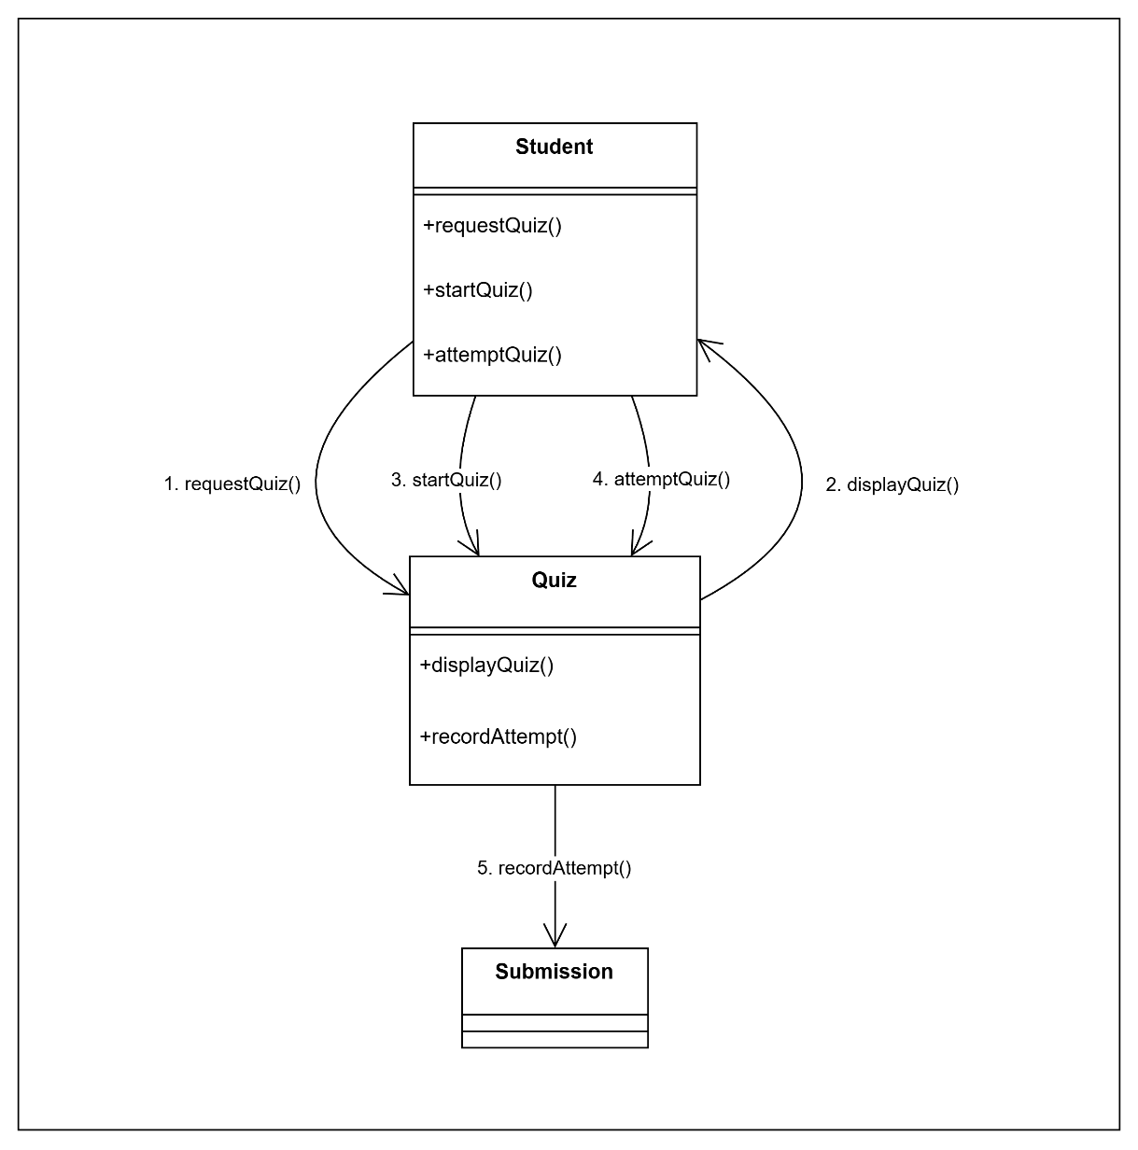
- This collaboration diagram shows how Student, Quiz, and Submission objects interact during quiz initiation.
- It highlights object relationships and message flow during quiz attempt.

2.Quiz Submission and Evaluation
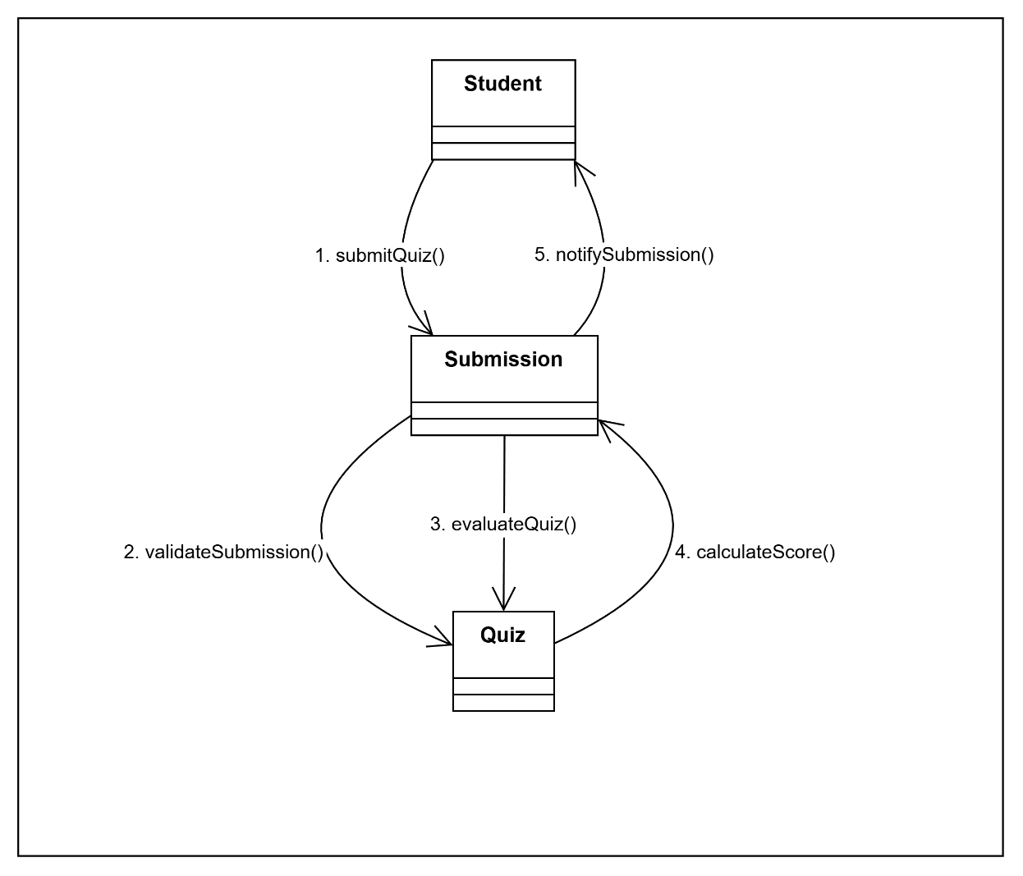

- This collaboration diagram represents how objects cooperate during quiz evaluation.
- It focuses on message exchange between Student, Submission, and Quiz.

- View Quiz Result
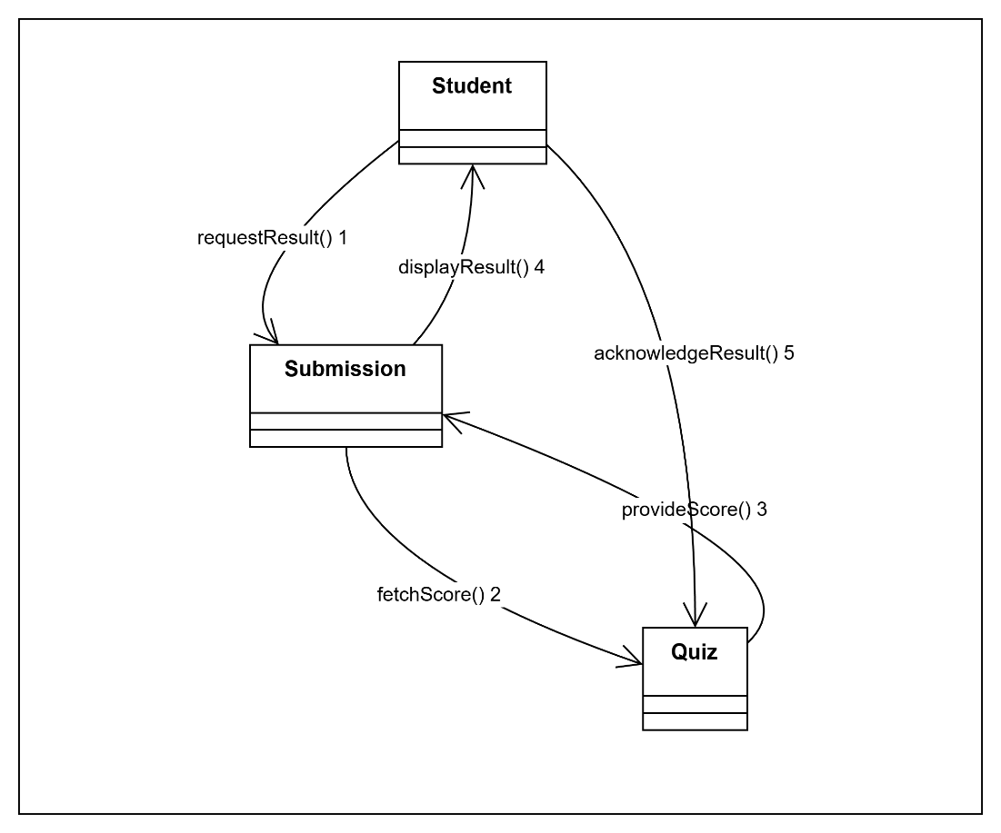
- This collaboration diagram shows how objects interact to display quiz results.
- It emphasizes collaboration between Student, Submission, and Quiz.

  - ER Diagram
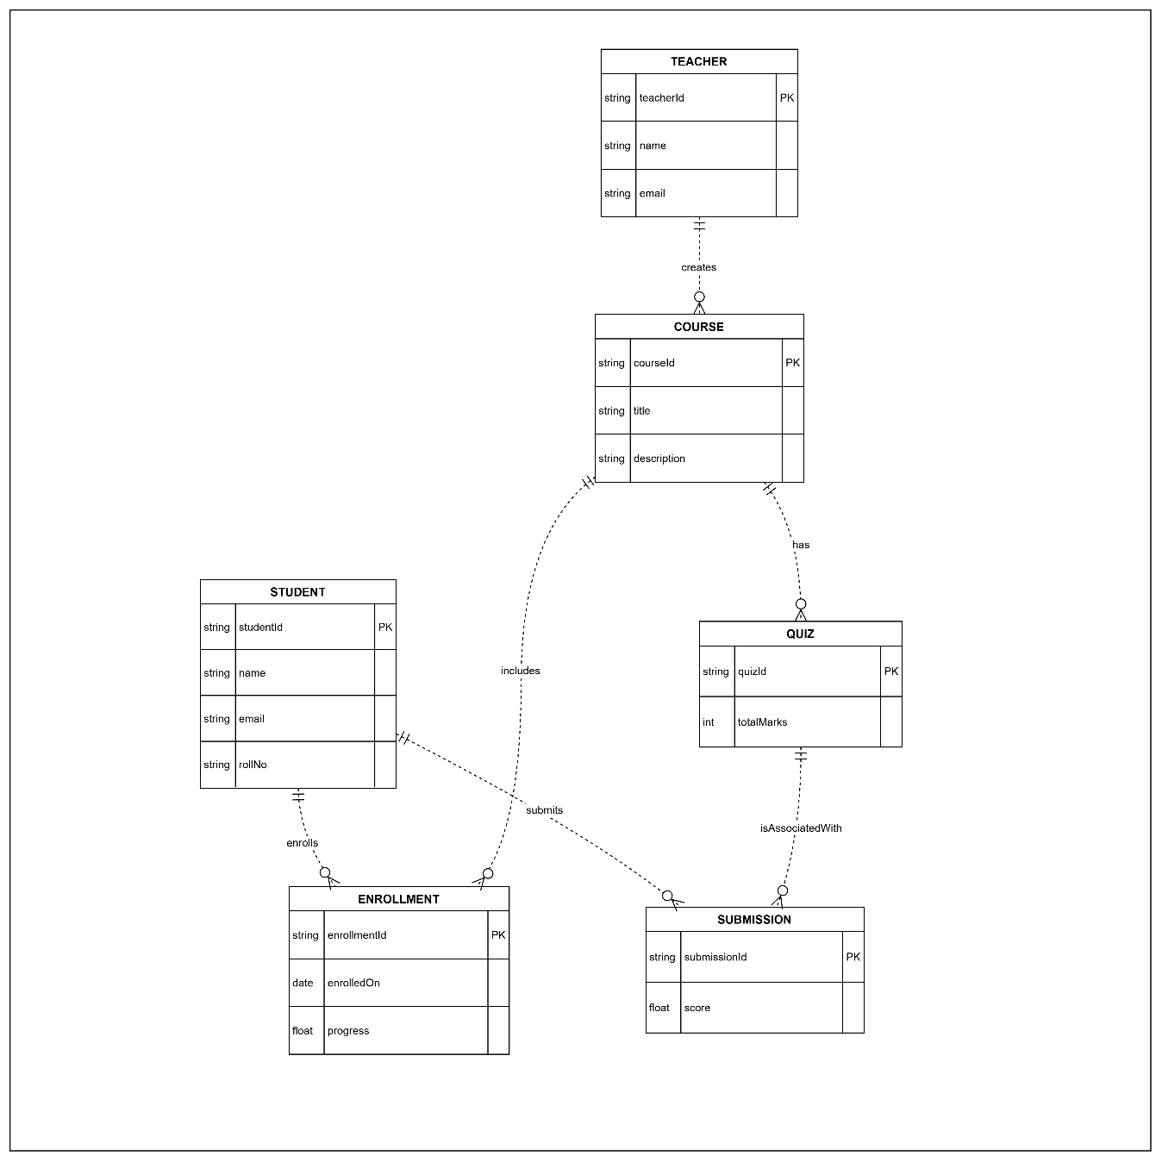
- The ER diagram represents the data structure of the Interactive Learning Platform.
- It shows the main entities involved in the system and their relationships.
- The diagram helps in understanding how data is stored and connected in the database.
- It supports core features such as user management, courses, quizzes, and submissions.

  - Data Flow Diagram
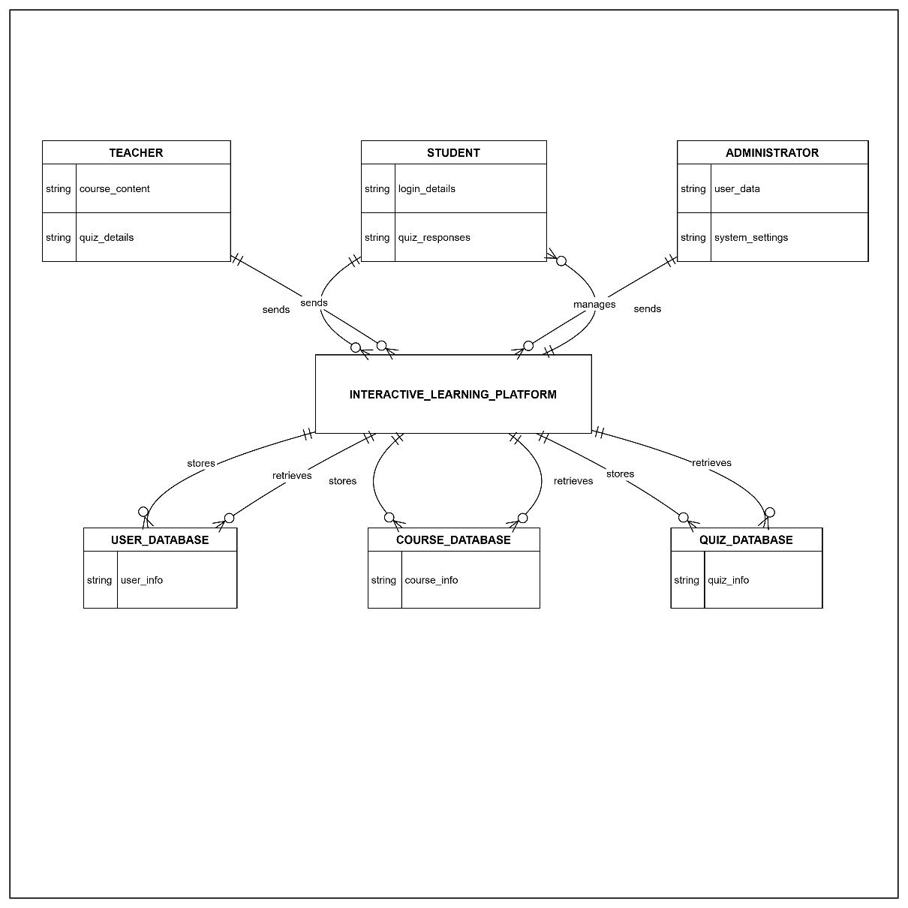

- The Level 0 Data Flow Diagram represents the overall flow of data in the system.
- It provides a high-level view of how external entities interact with the system.
- The diagram shows major processes and data stores without internal details.
- It helps in understanding system boundaries and data movement.

4. External Interface Requirements / Screenshots
This section describes the external interfaces of the Interactive Learning Platform. It explains how users interact with the system and how the system communicates with hardware, software, and network components. These interfaces help define the overall usability and accessibility of the system.
4.1 User Interfaces
- The Interactive Learning Platform provides a simple, intuitive, and user-friendly interface.
- The system is accessed through a web-based interface that can be opened using a standard web browser.
- Different users such as students, teachers, and administrators are provided with separate dashboards based on their roles.
- Students can view enrolled courses, access learning materials, attempt quizzes, track progress, and view results.
- Teachers can upload course content, create and manage quizzes, and evaluate student submissions.
- Administrators can manage users, configure system settings, and monitor system usage.
- The interface uses clear navigation menus, forms, buttons, and alerts to guide users and reduce confusion.
- Screens are designed to be consistent across the platform to improve ease of use.

4.2 Hardware Interfaces
- The Interactive Learning Platform does not depend on any specialized hardware.
- Users can access the system using commonly available devices such as desktops, laptops, tablets, and smartphones.
- Input devices like keyboard, mouse, or touch screen are used to interact with the system.
- Output is displayed through standard display devices such as monitors or mobile screens.
- The backend of the system runs on server hardware that stores data and handles user requests efficiently.
4.3 Software Interfaces
- The platform operates through modern web browsers such as Google Chrome, Mozilla Firefox, and Microsoft Edge.
- The system interacts with a backend database that stores user information, course details, quizzes, enrolments, and submissions.
- A web server processes user requests and provides appropriate responses.
- The system may integrate authentication services for user login and access control.
- All software components are designed to work together smoothly to ensure reliable system operation.

4.4 Communication Interfaces
- The system communicates over the internet using standard protocols such as HTTP and HTTPS.
- Secure communication is ensured using HTTPS for transmitting sensitive data like login credentials and quiz responses.
- Data is exchanged between the client and server in a structured format.
- The platform supports continuous communication between users and the system during activities such as quiz attempts and result viewing.
- Network communication is designed to be reliable under normal operating conditions.

5. Other Non-Functional Requirements
This section defines the non-functional requirements of the Interactive Learning Platform. These requirements describe the system’s quality attributes such as performance, security, and reliability, which are essential for overall system effectiveness.
5.1 Performance Requirements
- The system should provide quick responses to user actions such as login, course selection, and quiz submission.
- Page load times should be minimal under normal usage conditions.
- The platform should support multiple users accessing the system at the same time.
- Quiz evaluation and result display should be completed without noticeable delay.
- The system should maintain stable performance during peak usage periods.
5.2 Safety Requirements
- The system should protect data from accidental loss or corruption.
- Regular data backups should be maintained to ensure recovery in case of failure.
- Proper error handling mechanisms should be implemented to avoid system crashes.
- The system should ensure correct processing of quiz submissions and results.
- User actions should not result in unintended data modification.

5.3 Security Requirements
- All users must authenticate themselves before accessing the system.
- Access to system features is restricted based on user roles.
- User passwords and sensitive information must be stored securely.
- The system should prevent unauthorized access and data misuse.
- Secure communication channels should be used to protect data during transmission.
5.4 Software Quality Attributes
- Usability: The system should be easy to learn and use for all types of users.
- Reliability: The platform should function correctly with minimal failures.
- Scalability: The system should be able to handle an increase in users and data.
- Maintainability: The system should be easy to update and modify when required.
- Availability: The system should be accessible to users whenever needed.
5.5 Business Policies / Rules
- Users must log in to access system features.
- Students are allowed to attempt quizzes only for courses they are enrolled in.
- Teachers are responsible for creating, updating, and evaluating quizzes.
- Administrators manage user accounts and system configurations.
- All users must follow institutional policies while using the platform.

6. Testing
Testing is performed to ensure that the Interactive Learning Platform behaves correctly for both users and internal processes. Since the platform allows students to attempt quizzes, receive grades, and track learning progress, it is important to verify that these operations work reliably.
In this project, two complementary testing approaches are used:
- Black Box Testing – to verify functional behaviour such as grading results based on student marks.
- White Box Testing – to verify the internal logic used by the platform when evaluating quiz submissions.
To demonstrate these techniques, two Python programs are implemented that simulate core operations of the platform.

6.1 Black-Box Testing
Black box testing focuses on validating system behaviour based only on inputs and outputs. The internal code structure is not examined during this process.
For the Interactive Learning Platform, black box testing is applied to the grading functionality. This functionality represents how the platform calculates student performance after quizzes or assessments.
The testing checks whether correct grades are produced for different sets of marks entered by users.
6.1.1 Program Used for Black Box Testing
The program simulates the grading mechanism of the Interactive Learning Platform. Students receive marks for quizzes, and the system determines their grade based on the average score.
The implementation uses Python’s statistics library to calculate the average marks.

Black Box Program:
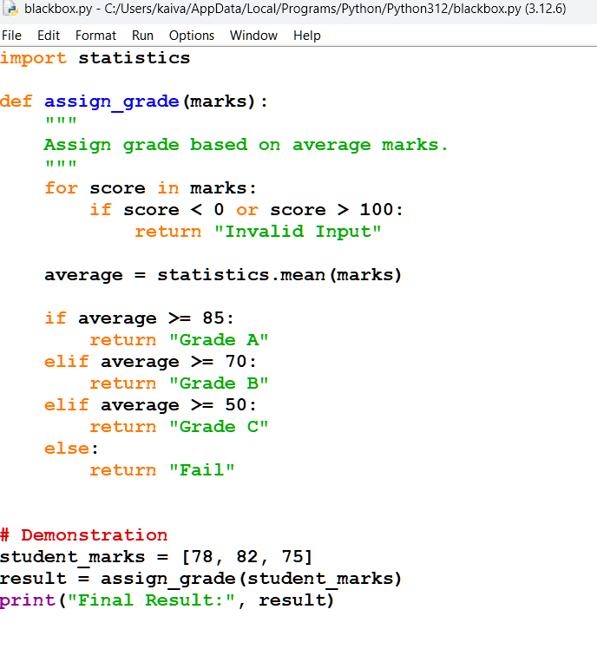
6.1.2 Purpose of the Program
This program represents how the platform evaluates student performance after completing assessments. The grading process is important because it allows students to understand their learning progress and enables teachers to monitor academic performance.
6.1.3 Equivalence Partitioning
Equivalence partitioning divides the input values into groups that should produce similar outputs.
For the grading functionality, the input groups include:
- Marks below 0 → Invalid input
- Marks between 0 and 100 → Valid input
- Marks above 100 → Invalid input
Based on average marks, the grade categories are:
- Average ≥ 85 → Grade A
- Average between 70 and 84 → Grade B
- Average between 50 and 69 → Grade C
- Average < 50 → Fail

6.1.4 Boundary Value Analysis
Boundary value analysis focuses on testing the extreme values near the limits of valid input.
Important boundaries for the grading system include:
- 0 and values slightly below it
- 50 (minimum passing boundary)
- 70 (boundary for Grade B)
- 85 (boundary for Grade A)
- 100 and values slightly above it
Testing these boundaries ensures the grading system works correctly at critical points.
6.1.5 Black Box Test Cases
Test Case ID | Input Marks | Expected Output
BB1 | [-5, 80] | Invalid Input
BB2 | [45, 48] | Fail
BB3 | [50, 55] | Grade C
BB4 | [70, 75] | Grade B
BB5 | [85, 90] | Grade A
BB6 | [105, 70] | Invalid Input

6.1.6 Program Output
When the program is executed in Python IDLE, the output appears as follows:
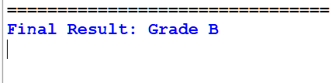
This confirms that the grading function correctly calculates the student’s grade based on the input marks.

6.2 White Box Testing
White box testing focuses on analysing the internal structure of the program. The objective is to ensure that all logical paths in the code are executed at least once.
In the Interactive Learning Platform, white box testing is applied to the quiz submission evaluation logic. This logic represents how the platform checks student answers, calculates scores, and determines performance status.

6.2.1 Purpose of the Program
The purpose of the quiz evaluation program is to simulate how the Interactive Learning Platform processes quiz submissions. When a student submits answers for a quiz, the system verifies the validity of the submission and evaluates each answer.
The program compares submitted answers with the correct answers, calculates the total score, and determines the performance level based on the percentage obtained. This evaluation mechanism allows the platform to provide feedback to students and helps instructors assess student performance effectively.

6.2.2 Program Used for White Box Testing
The program evaluates a student's quiz submission by comparing the submitted answers with the correct answers.
White Box Program:
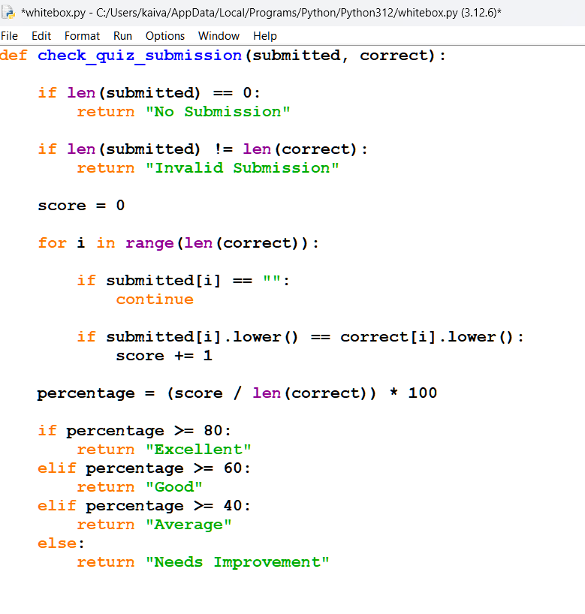

6.2.3 Control Flow Diagram
The control flow diagram illustrates the sequence of operations performed during the quiz evaluation process. Each node in the diagram represents a specific operation or decision in the program.
The diagram helps visualize how the program processes different input conditions and allows identification of independent execution paths required for white box testing.
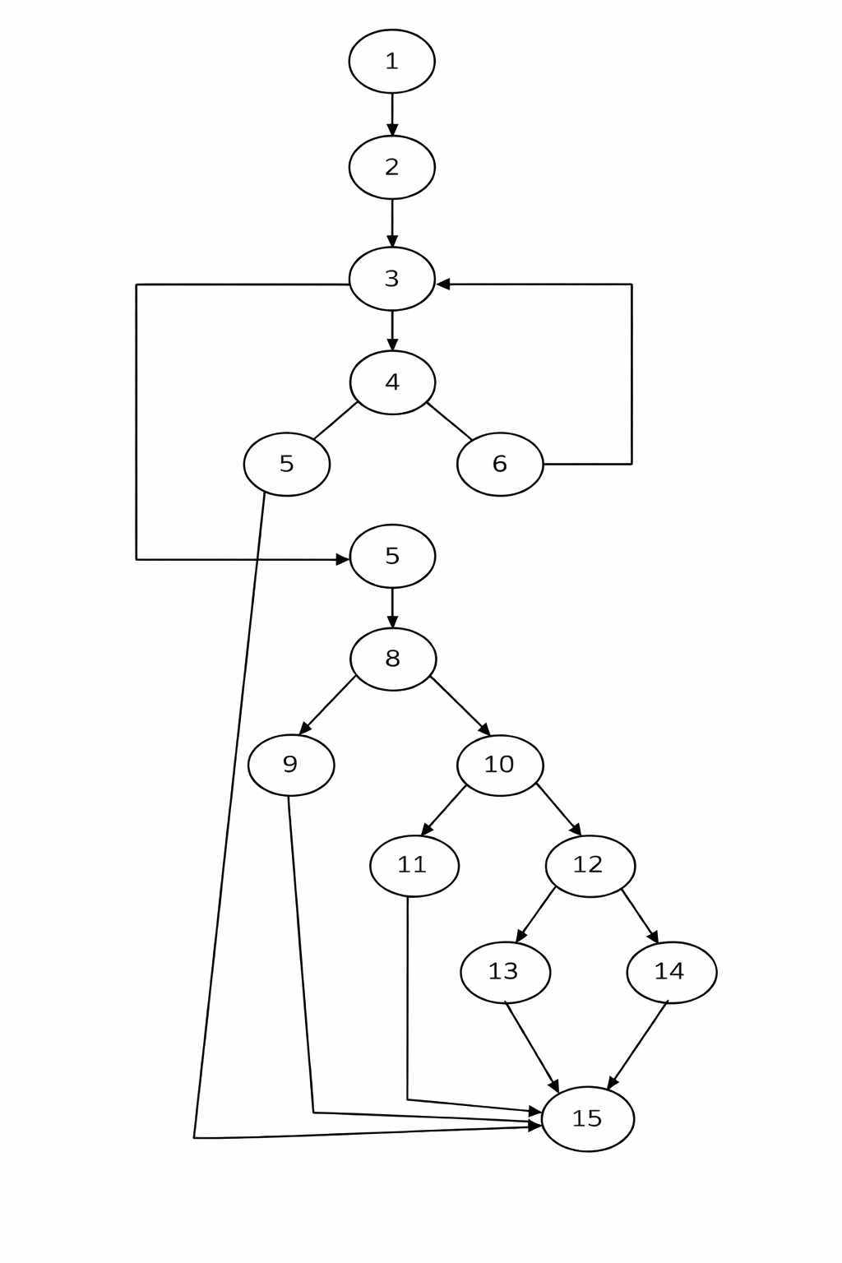
6.2.4 Control Flow Explanation
Each numbered node in the control flow diagram represents a step in the program execution.
1 – Start of program execution.
2 – Receive submitted answers and correct answer key.
3 – Check if the submission list is empty.
4 – Verify whether the number of submitted answers matches the number of questions.
5 – Initialize the score variable.
6 – Handle invalid submission condition.
7 – Begin processing answers one by one.
8 – Check whether the current answer is blank.
9 – Skip blank answer and continue processing.
10 – Compare the submitted answer with the correct answer.
11 – Increase the score if the answer is correct.
12 – Continue processing remaining answers.
13 – Calculate the percentage score obtained.
14 – Determine the student's performance category.
15 – End of program execution.

6.2.5 Cyclomatic Complexity
Cyclomatic complexity measures the number of independent execution paths in a program. It helps determine the minimum number of test cases required for complete path coverage.
The cyclomatic complexity is calculated using the formula:
V(G) = P + 1
Where:
P = Number of decision nodes.
Based on the control flow diagram, the number of decision nodes is 5.
Therefore,
V(G) = 5 + 1
V(G) = 6
This indicates that six independent paths exist in the program.

6.2.6 Independent Paths
The following independent paths can be derived from the control flow diagram:
Path 1
1 → 2 → 3 → 15
Path 2
1 → 2 → 3 → 4 → 6 → 3 → 15
Path 3
1 → 2 → 3 → 4 → 5 → 7 → 8 → 9 → 15
Path 4
1 → 2 → 3 → 4 → 5 → 7 → 8 → 10 → 11 → 15
Path 5
1 → 2 → 3 → 4 → 5 → 7 → 8 → 10 → 12 → 13 → 15
Path 6
1 → 2 → 3 → 4 → 5 → 7 → 8 → 10 → 12 → 14 → 15
These paths ensure that all logical conditions and decisions in the program are executed during testing.

6.2.7 White Box Test Case Program
The quiz evaluation function is tested using Python's unittest library. Each test case executes a different logical path in the program.
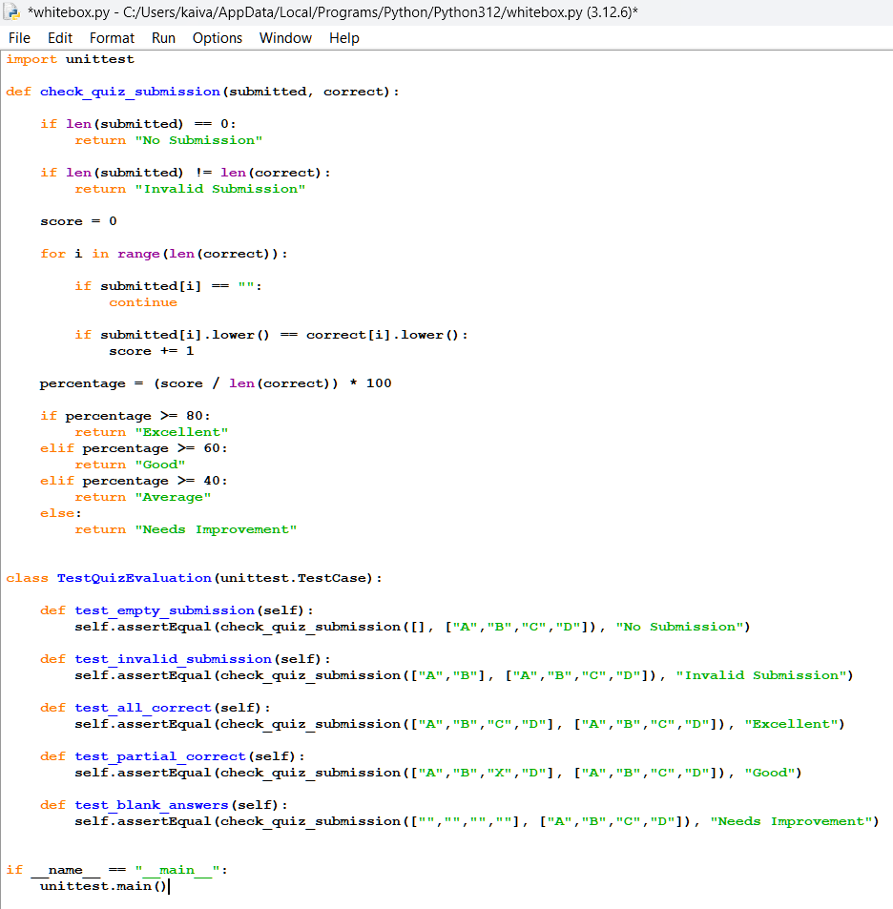

6.2.8 Output
When the program is executed in Python IDLE, the following output is obtained:
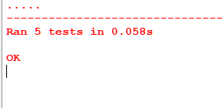
This output indicates that all test cases executed successfully and the program behaves correctly for different input conditions.

7. Conclusion
The Software Requirement Specification for the Interactive Learning Platform describes the functional and non-functional requirements of the proposed system. The document defines the system scope, user roles, system behaviour, and the main features that support online learning activities.
The platform is designed to provide a simple and accessible environment where students can access learning materials, attempt quizzes, and monitor their academic progress. Teachers are able to manage course content and evaluate student performance efficiently, while administrators maintain system configuration and user management.
Various diagrams such as UML diagrams, ER diagrams, DFD diagrams, and testing models were developed to represent the system structure, data flow, and interaction between system components. These diagrams help in understanding the system architecture and assist developers in implementing the platform correctly.
Overall, the Interactive Learning Platform aims to improve learning accessibility, simplify assessment processes, and support a structured digital learning environment.

8.References
- W3Schools, Python Programming Documentation, https://www.w3schools.com
- UML Diagrams Reference – Object Management Group (OMG), https://www.omg.org
9.Acknowledgements
I would like to thank the faculty of the School of Computer Science and Engineering for providing the guidance and resources required to complete this project.
I also acknowledge the course instructor for explaining the concepts of software engineering and system design which helped in preparing this Software Requirement Specification.

Design Architecture

10.Design Architecture
The design architecture of the Interactive Learning Platform describes how the major parts of the system are organized and how they interact with each other. The architecture divides the system into logical components that handle specific responsibilities such as user interaction, course management, content delivery, and quiz evaluation.
This architectural structure helps developers understand how the system processes user requests and manages learning activities. It also ensures that the system remains modular, scalable, and easier to maintain.
The architecture of the Interactive Learning Platform is represented using component diagrams and deployment diagrams, which illustrate the software modules and the physical environment in which the system operates.
10.1 Component Diagram
The component diagram represents the main software modules of the Interactive Learning Platform and the relationships between them. Each component performs a specific function within the system and communicates with other components to complete system operations.
The diagram helps illustrate how different modules such as authentication, course management, and quiz evaluation work together to support the learning process.
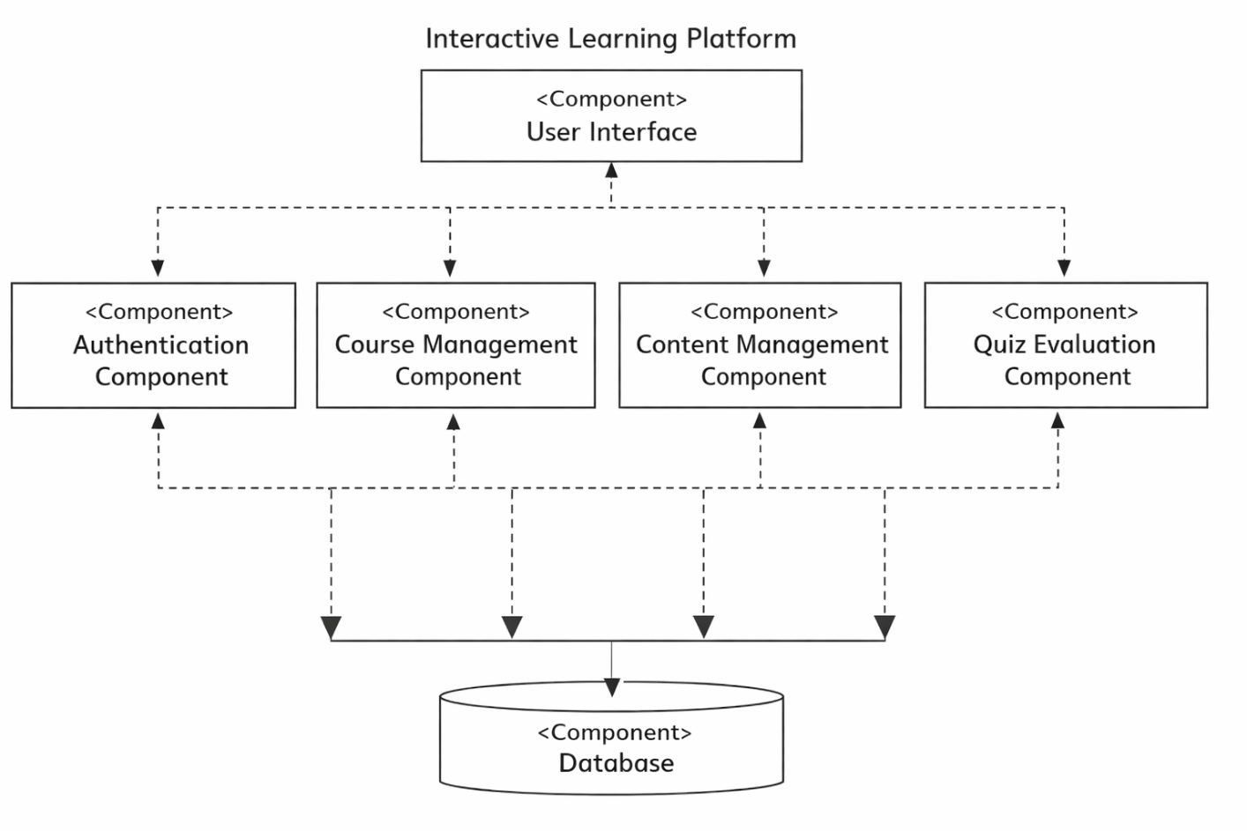
10.1.1 Components and Their Functions
User Interface Component
The user interface component allows users to interact with the system through a web browser. It provides dashboards and pages for students, teachers, administrators, and management users.
Functions include:
- displaying login pages and dashboards
- allowing students to access courses and quizzes
- enabling teachers to upload materials and create quizzes
- displaying results and progress information
Authentication Component
The authentication component manages user verification and system access.
Functions include:
- validating login credentials
- managing user sessions
- controlling access based on user roles

Course Management Component
The course management component handles all course related activities.
Functions include:
- creating courses
- enrolling students in courses
- managing course information
Content Management Component
The content management component manages learning materials available on the platform.
Functions include:
- uploading learning resources
- organizing study materials
- linking content to courses
Quiz Evaluation Component
The quiz evaluation component manages assessments.
Functions include:
- processing quiz attempts
- evaluating quiz submissions
- calculating scores and results
Database Component
The database component stores all system data including user accounts, courses, learning materials, quizzes, and results.
All system components interact with the database to store and retrieve information.

10.1.2 Relationships Between Components
The components interact with each other to provide complete system functionality.
- The User Interface component sends user requests to backend components.
- The Authentication component verifies user identity before granting access.
- The Course Management component manages course related operations.
- The Content Management component organizes learning materials for courses.
- The Quiz Evaluation component processes quiz submissions and calculates results.
- The Database component supports all modules by storing and retrieving system data.
These interactions ensure proper coordination between different modules of the system.

10.2 Deployment Diagram
The deployment diagram represents the physical environment in which the Interactive Learning Platform operates. It shows how the system is distributed across hardware devices and how these devices communicate with each other.
Users access the system through client devices using a web browser. These devices communicate with the server through the internet. The server processes user requests and interacts with the database server where all system data is stored.
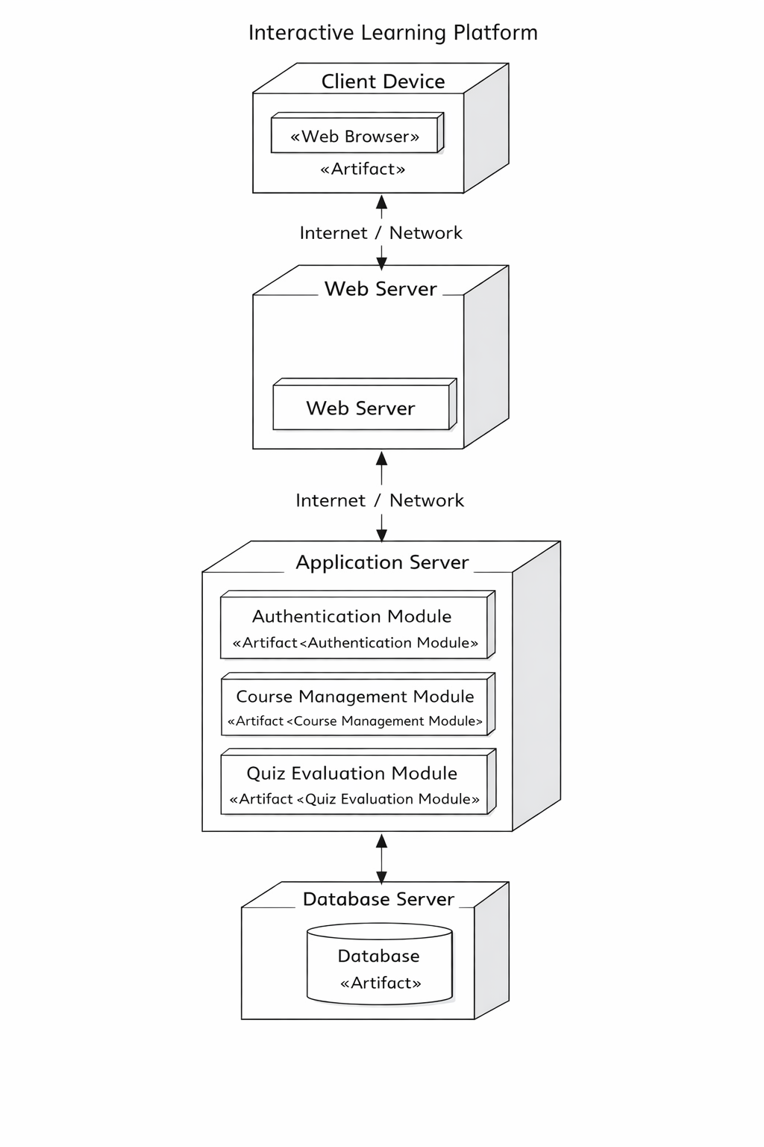
10.2.1 Deployment Environment
The platform is implemented as a web-based system. Users access the system using devices such as laptops, desktops, tablets, or mobile phones.
The client device communicates with a web server through the internet. The web server forwards requests to the application server where the main system logic is executed.
The application server communicates with the database server which stores all system information.
10.2.2 Nodes and Their Functions
Client Device
Represents user devices such as computers or mobile phones used to access the system through a web browser.
Web Server
Handles incoming requests from users and provides the web interface of the system.
Application Server
Processes system operations such as authentication, course management, content management, and quiz evaluation.
Database Server
Stores all system data including users, courses, quizzes, submissions, and results.

11.1 Function Point Analysis (FPA)
- Function Point Analysis is used to estimate the size of the Interactive Learning Platform based on the functionality it provides to users. Instead of focusing on code, it evaluates system features such as inputs, outputs, files, and user interactions.
- In this project, FPA is applied to key functionalities like login, course management, content access, and quiz evaluation.

11.1.1 Identification of Functional Components
- The main features of the Interactive Learning Platform are mapped to FPA parameters:
External Inputs (EI)
- User login and registration
- Course enrolment
- Quiz submission
- Uploading study materials

External Outputs (EO)
- Display of quiz results
- Student performance reports
- Confirmation messages
External Inquiries (EQ)
- Viewing course details
- Checking quiz results
- Tracking progress
Internal Logical Files (ILF)
- User data (students, teachers, admin)
- Course database
- Quiz and submission data
- Enrolment records
External Interface Files (EIF)
- External data sources (if integrated in future)

11.1.2 Calculation of UFP
Component | Count | Weight | Total
External Inputs (EI) | 5 | 4 | 20
External Outputs (EO) | 4 | 5 | 20
External Inquiries (EQ) | 3 | 4 | 12
Internal Logical Files (ILF) | 4 | 10 | 40
External Interface Files (EIF) | 2 | 7 | 14
- UFP = 106
11.1.3 Complexity Adjustment Factor (CAF)
- The system includes features like:
- secure login
- real-time quiz evaluation
- multiple user roles
- continuous data interaction
- Assuming average complexity:
- ΣFi = 42
- CAF = 0.65 + (0.01 × 42)
CAF = 1.07

11.1.4 Final Function Points
- FP = UFP × CAF
- FP = 106 × 1.07
FP = 113 Function Points (approximately)

11.1.5 Interpretation
- The calculated function points indicate the functional size of the Interactive Learning Platform.
- This reflects:
- moderate system complexity
- multiple user interactions
- structured data handling
- The result can be used to estimate development effort and system scale.

11.2 COCOMO Model
The COCOMO model is used to estimate the effort, development time, and number of developers required for the Interactive Learning Platform. The estimation is based on the size of the system measured in KLOC (thousands of lines of code).
11.2.1 System Size Estimation
The Interactive Learning Platform consists of the following modules:
- User Management
- Course Management
- Content Management
- Quiz Evaluation
- Enrolment & Progress
Based on the functionality and complexity of these modules, the estimated size of the system is:
KLOC = 20

11.2.2 Project Type
The project is classified as an Organic Project because:
- requirements are well understood
- system complexity is moderate
- similar systems already exist
- small development team is sufficient
11.2.3 Effort Calculation
Formula:
E = A × (KLOC)^B
For Organic mode:
A = 2.4
B = 1.05
E = 2.4 × (20)^1.05
E = 2.4 × 27.34
E ≈ 65.6 Person-Months

11.2.4 Development Time
Formula:
T = 2.5 × (E)^0.38
T = 2.5 × (65.6)^0.38
T ≈ 2.5 × 5.2
T ≈ 13 Months
11.2.5 Team Size
Persons Required = Effort / Time
= 65.6 / 13
≈ 5 Developers
11.2.6 Final Result
Parameter | Value
Project Size | 20 KLOC
Effort | 65.6 Person-Months
Development Time | 13 Months
Team Size | 5 Developers

11.2.7 Interpretation
The COCOMO estimation shows that the Interactive Learning Platform requires moderate development effort and can be completed within a reasonable time using a small team. This aligns with the system features such as user management, content delivery, and quiz evaluation.

